LEVERAGING HIERARCHICAL GRAPH ATTENTION NETWORKS FOR MENTAL REPRESENTATION INFERENCING
Muhammad Fusenig
Robert Slevc
University of Maryland, College Park

Abstract
Despite numerous advancements in reading comprehension (RC) models, many fail to adequately account for the role of memory in word sense-making and the dynamic construction of mental representations during reading. Existing computational approaches focus heavily on mechanistic processes like word identification and disambiguation, often neglecting how memory storage and retrieval shape comprehension in real-time, adaptive contexts. To address these limitations, we propose a Hierarchical Graph Attention Network (HGAN) that models memory storage, activation, and retrieval processes in RC. Our model integrates linguistic propositional arguments and experimental constraints within a neuro-symbolic architecture to emulate modular subsystems, balancing external task complexity with internal cognitive representations. Additionally, an encoder-decoder network is employed alongside a "Take the Best" algorithm to enable rapid, computationally efficient inference of text, leveraging multimodal sense data to construct interpretable mental representations. This novel framework offers a theoretically robust and computationally efficient model of memory-driven reading comprehension, bridging symbolic and connectionist paradigms to capture the evolving interplay of memory, reasoning, and contextual adaptation.

Background
Reading Comprehension: A Cognitive Challenge
Reading comprehension (RC) is among the most fundamental yet cognitively complex processes that individuals engage in (Duke and Carlisle, 2010). Transforming linguistic symbols into meaningful concepts, retaining that information, and drawing upon it when needed has been the focus of intense theoretical and empirical study for decades (Joshi, 2000; Duke, 2010; Perfetti, 2014).
Existing RC models, such as the Componential and Active View models, have highlighted key factors influencing comprehension, including inference-making strategies, background knowledge, and individual motivation (Joshi and Aaron, 2000; Duke and Cartwright, 2021). These models provide valuable insights into the interplay of cognitive and social differences that shape RC ability. However, these models have struggled to account for how such factors influence RC in real-time, dynamic environments with variable contextual stimulus.
This challenge is further complicated by fundamental questions about how memory systems store and retrieve information and how these processes interact with external stimuli. As argued in scholarship of enactivist cognition, phenomenological sense—the ability to make meaning from experiences—emerges from a combination of prior memory activations and the integration of novel perceptual stimuli (Gallagher, 1997; Gallagher 2017). This suggests that traditional RC models that do not account for prior memory may fall short of fully capturing the fluidity and complexity of underlying cognitive processes that inform comprehension, particularly as they unfold over time and across different contexts.

The Promise of Hierarchical Graph Attention Networks
To address these challenges, Hierarchical Graph Attention Networks (HGANs) offer a novel framework for modeling the intricate cognitive processes underlying RC. HGANs enable the representation of cognitive and contextual factors as nodes and encode their relationships as edges within a dynamic, hierarchical structure (Veličković et al., 2017; Sobolevsky 2021). Unlike static models, HGANs can provide an interpretable framework for integrating multimodal perceptual inputs from the environment, allowing the model to adapt to shifting task demands (Schapiro et al., 2012; Nastase et al. 2021).
This dynamic modeling approach situates cognition as an active, embodied process, capable of accounting for both individual differences and contextual influences. HGANs provide a mechanism to operationalize the factors associated with traditional RC theories by mapping the interactions of cognitive subsystems and their contributions to memory and comprehension. Through these structures, HGANs can capture the evolving mental representations that underpin RC, offering a more comprehensive and interpretable model of this critical cognitive process.

Theoretical Framework
Reasoning and memory are foundational cognitive processes that underpin reading comprehension and mental representation. A key component of reading comprehension is the ability to infer word meanings and causal relationships within a given text (Duke, 2010; Perfetti, 2014). This inferencing process is critical for transforming linguistic symbols into meaningful concepts and for constructing coherent mental representations of the information being read.

Reasoning
Traditional reasoning models suppose a multitiered memory system in which short-term and long-term memory constraints influence one’s capacity for reasoning (Rugg, 2003; Chun, M. M. & Turk-Browne, 2007). In this view, mental objects are accessed and manipulated either simultaneously or in rapid succession within working memory to determine the veridicality of facts or predictions. Practically speaking, a reasoning algorithm must account for two primary components: (a) the characteristics and dimensions of the objects being reasoned over and (b) the selection algorithm that organizes and sequentially transforms mental objects. The relationship between these two components determines the ability of an information processing system (IPS) to engage in effective reasoning. As Simon (1990) observed, reasoning is dependent on “the structure of task environments and the computational capabilities of the actors (Simon 1990).” These components allow for either the construction or decomposition of objects into features and sub-features across multiple time steps. This process allows objects to be re-analyzed and defined, updating mental states, activating memory, and enabling decision-making to address underlying goals.

Memory
Memory serves as the foundation for reasoning, enabling the storage, retrieval, and manipulation of mental objects (Hayes et al., 2014; Sherman et al., 2023). Traditional theories of memory emphasize a multitiered structure, where short-term and long-term memory constraints influence the process of reasoning (Atkinson & Shiffrin, 1968; Baddeley & Hitch, 1974). These systems allow for the rapid retrieval of heuristics from long-term memory to facilitate quick decisions, while deliberative operations in working memory enable more accurate reasoning by engaging mental objects in greater depth (Tversky & Kahneman, 1974; Squire, 2009).
In this view, specific memories are retrieved and operated over in workspaces. According to alternative views, such as those put forward by Sherman et al. (2023), memory is understood not simply as an archive of past experiences but as a dynamic interplay between previous experience and novel perceptual stimuli. These patterns are influenced by prior experiences and continuously shaped by ongoing perceptual inputs, leading to novel mental representations. Downstream reasoning is thus viewed as a set of mental operations over retrieved and generated representations. This iterative process of memory activation and updating of continually changing mental representations brings into question discrete representations of memories and mental objects.
Recent advances in cognitive neuroscience corroborate these more dynamic theories of memory storage, suggesting that activation patterns across seemingly disparate brain regions are not redundancies but instead contribute meaningfully to memory activation and retrieval processes (Sherman et al., 2023). These relationships influence both attentional mechanisms—guiding the generation of objects from the total set of perceptual stimuli—and the phenomenological experience of these objects, encompassing both unconscious and conscious appraisals (Baars et al., 2021; Sherman & Turk-Browne, 2024). These findings challenge traditional theories of multi-part memory systems, the use of heuristics, and unitary representations within localized brain regions, leading to more dynamic models and theories of memory activation.

Challenges With Current Reading Comprehension Models
While reasoning and memory are foundational to reading comprehension, existing RC models fail to capture the nuance and relationship between these two processes. A majority of models of RC do not fully account for how memory retrieval and reasoning processes adapt to contextual demands or integrate perceptual inputs to construct meaningful representations. This has resulted in a gap between models that can bridge mechanistic processes, such as word identification, with higher-order cognitive functions, such as inference and decision-making.
RC models fall into two camps: Connectionist vs. Symbolic. Connectionist models, while powerful in their focus on mechanistic processes, often struggle to incorporate higher-order cognitive factors, such as individual differences and ecological variables. Rule-based, symbolic models, on the other hand, rely on static frameworks that fail to adapt to dynamic, real-world environments where contextual factors influence cognition. These models have also been criticized for their inability to represent the full complexity of mental processes, particularly in how memory and reasoning interact to construct meaningful representations (Sprevak, 2023).
Moreover, traditional memory models often assume distinct, competing subsystems for short- and long-term storage. This segmentation has been called into question by growing evidence suggesting that brain regions associated with memory are part of a more unified network, where overlapping activation patterns contribute to memory retrieval and application (Sherman et al., 2023). Current models also struggle to account for the relational and dimensional characteristics of mental objects—features that influence reasoning accuracy and the ability to adapt to novel tasks (Kendeou & O'Brien, 2018).

Model Architecture
To address these challenges, the proposed model leverages a Hierarchical Graph Attention Network (HGAN) architecture, designed to integrate perceptual inputs, memory retrieval processes, and reasoning mechanisms into a unified, context-sensitive framework. The model has four distinct parts, (a) an encoder network responsible for attenuating to relevant objects and distilling mental representations into memory; (b) an HGAN memory network representative of underlying neurological imaging data; (c) a decoder network that processes the memory network data into operable mental objects; and (d) a reasoning module that aggregates and reasons over the generated mental objects utilizing a Take the Best Algorithm.

Encoder Network
The model leverages a series of encoder networks that consolidate perceptual stimulus into an integrated HGAN-based memory network. Each level in the encoder can be specified to possess certain values or can be instantiated with the outputs of a discrete, symbolic modular system. Additionally, compared to a fully encapsulated system, this structure allows complex reorganization in the training process. A fully encapsulated, modular system can be used to produce outputs that would be used to constrain a particular layer. (a) Contains an attention map that allows the model to attenuate to various objects in the environment. This attention map is refined during the backpropagation of the training phase. (b) The implementation of sub features as constrained nodes derived from relevant modular or connectionist sub systems. I.e. phonographic, orthographic, syntactic processing units, etc. (c) Distillation of relevant features, via encoding. Aggregates the influence of such features on an output node. (d) The Output node corresponds to a memory key value that (in combination with other perceptual encoder networks) leads to particular activation of memory, which subsequently triggers the propagation of activation patterns across the memory network, forming a cascade of contextually relevant mental states and representations. This means that the encoded features serve as keys or cues that access and retrieve relevant stored information within memory that will be useful for later downstream processes.

Memory Network
The memory network architecture is informed by an enactivist interpretation of embodied cognition that simultaneously accounts for and integrates perceptual stimuli from the environment and individual information processing subsystems into memory. As such, inputs from across perceptual modalities are distilled and consolidated to operate on a shared underlying graphical representation of active brain regions and neural activity. First, neural imaging of brain regions is conducted. Second, relevant features are extracted via pretrained convolutional neural networks. Third, identified brain activation patterns are converted to graphical representations and labeled with respect to the relevant behavioral data. In this case, the sequencing of word identification. The result is a graphical representation that captures neural activation patterns associated with word identification in corresponding brain regions. Varying activations result in differentiable weighting of nodes and edges. Fourth, the aforementioned graphical representations are aggregated to create a unified HGAN. Connections between nodes with temporally or functionally correlated activation patterns are established. Fifth, an additional layer is created, synthesizing activated nodes into consolidated graphical representations, allowing for a compressed representation of underlying brain activation patterns.

Decoder Network
The decoding process begins with the transformation of graphical data from the memory network into structured representations. During decoding, the network translates the graphical data in memory into structured representations that mirror the actions or decisions made during reading comprehension tasks. These outputs capture how specific mental representations or memory activations contribute to key processes, such as inferencing, word disambiguation, or the integration of new information. Errors in prediction are corrected through backpropagation during training, ensuring that the decoder refines its outputs to closely match observed outcomes while preserving interpretability.
Similar to the encoder network, several deep learning layers integrate propositional and linguistic constraints. These constraints are preconfigured functions within respective deep learning layers that serve to guide the model during training. These constraints may include perceptual stimuli and word-sense categories. The interjection of such constraints simulate modular output that can be operated over by the neural network.
The result is symbolic and connectionist representations that self-organize to predict a set of operable mental representations. These representations, given their unique processing history, possess respective weights that will be aggregated into a Take Best Reasoning Algorithm. Node weights represent the sparsity and dimensionality of mental representation. The nodes are aggregated and used to predict the first likely satisficing optimum for a constrained reasoning task, this being word-sense making.

Take Best Algorithm
To model this process, we leverage the Take Best Algorithm, which offers greater computational efficiency and better predict human decision making compared to traditional reasoning models (Gigerenzer & Goldstein, 1996). In this model, the activation of underlying memory, combined with discrete mental processes, generates contextually relevant mental representations of external objects. Given additional stimuli—such as task demands or directions—these representations and their underlying values are used to predict next action states or satisfy a generative process leading to a “satisficing” local optimum. This optimum aggregates the set of mental representations to compute a choice or next action that maximizes a contextually relevant reward function. This reward function is variable, influenced by the characteristics, dimensions, and sequencing of the underlying mental representations. This results in a streamlined decision-making process, where the Take Best Algorithm efficiently translates mental representations from the decoder into some deliberative response that aligns with environmental and task-specific demands.

Results and Outcomes
Validation
The HGANs will be trained and tested on existing neurological and reading comprehension datasets such as the “Alice” and “Narratives” datasets to evaluate their predictive accuracy and interpretability (Bhattasali et al., 2020; Nastase et al., 2021). Their performance will be compared directly with traditional RC models to assess improvements in predicting comprehension outcomes. Optimization techniques, such as minimizing loss and error rates, will refine the models during training, while testing on unseen data will ensure their generalizability. By incorporating reinforcement learning and human feedback, the HGANs will be further adapted to capture cognitive processes effectively. This approach will allow the HGANs to provide more accurate and interpretable predictions of comprehension outcomes compared to traditional assessments.

Anticipated Model Outcomes
The proposed HGAN model is expected to deliver a robust, dynamic framework for representing memory storage, retrieval, and activation processes. By integrating modular subsystems and attention mechanisms, the model will generate stimulus-agnostic memory representations capable of adapting dynamically to task and environmental constraints. These representations will be discrete and interpretable, enabling the transformation of perceptual stimuli into higher-order mental constructs. By minimizing representational errors through the integration of linguistic and propositional constraints, the model ensures alignment with real-world data and experimental findings. Furthermore, its scalable architecture and integration of the Take Best Algorithm provides a computationally efficient framework for full scale cognitive models, extending beyond reading comprehension to support more general reasoning and inference-making tasks.
Such a model has significant theoretical and experimental implications within reading comprehension and beyond. By integrating connectionist and symbolic frameworks into a unified neuro-symbolic architecture via HGANs, this model operationalizes theories of memory activation and embodied cognition while remaining dynamic and interpretable. Such research advances understanding of how overlapping neural activation patterns contribute to memory retrieval and sense-making. Furthermore, the model provides a practical framework to test hypotheses about the sequencing and weighting of activation patterns, addressing persistent challenges in traditional memory models.

Works Cited

Atkinson, R. C., & Shiffrin, R. M. (1968). Human memory: A proposed system and its control processes. In K. W. Spence & J. T. Spence (Eds.), The psychology of learning and motivation (Vol. 2, pp. 89–195). Academic Press. https://doi.org/10.1016/S0079-7421(08)60422-3
Baars, B. J., Geld, N., & Kozma, R. (2021). Global Workspace Theory (GWT) and Prefrontal Cortex: Recent Developments. Frontiers in Psychology, 12. https://doi.org/10.3389/fpsyg.2021.749868
Baddeley, A. D., & Hitch, G. (1974). Working memory. In G. H. Bower (Ed.), The psychology of learning and motivation (Vol. 8, pp. 47–89). Academic Press. https://doi.org/10.1016/S0079-7421(08)60452-1
Bhattasali, S., Brennan, J., Luh, W.-M., Franzluebbers, B., & Hale, J. (2020). The Alice Datasets: fMRI & EEG observations of natural language comprehension. In N. Calzolari, F. Béchet, P. Blache, K. Choukri, C. Cieri, T. Declerck, S. Goggi, H. Isahara, B. Maegaard, J. Mariani, H. Mazo, A. Moreno, J. Odijk, & S. Piperidis (Eds.), Proceedings of the Twelfth Language Resources and Evaluation Conference (pp. 120–125). European Language Resources Association. https://aclanthology.org/2020.lrec-1.15
Borghi, A. M., Barca, L., Binkofski, F., Castelfranchi, C., Pezzulo, G., & Tummolini, L. (2018). Words as social tools: Language, sociality, and inner grounding in abstract concepts. Physics of Life Reviews. https://doi.org/10.1016/j.plrev.2018.12.001
Chun, M. M., Golomb, J. D., & Turk-Browne, N. B. (2011). A taxonomy of external and internal attention. Annual Review of Psychology, 62, 73–101. https://doi.org/10.1146/annurev.psych.093008.100427
Chun, M. M., & Turk-Browne, N. B. (2007). Interactions between attention and memory. Current Opinion in Neurobiology, 17(2), 177–184. https://doi.org/10.1016/j.conb.2007.03.005
Duke, N. K., & Carlisle, J. (2010). The development of comprehension. In M. L. Kamil, P. D. Pearson, E. B. Moje, & P. P. Afflerbach (Eds.), Handbook of reading research: Volume IV (pp. 199–228). Routledge. https://doi.org/10.4324/9780203840412
Duke, N. K., & Cartwright, K. B. (2021). The science of reading progresses: Communicating advances beyond the simple view of reading. Reading Research Quarterly, 56(Suppl 1), S25–S44. https://doi.org/10.1002/rrq.411
Gallagher, S. (1997). Mutual enlightenment: Recent phenomenology in cognitive science. Journal of Consciousness Studies, 4(3), 195–214.
Gallagher, S. (2017). Enactivist interventions: Rethinking the mind. Oxford University Press.
Gigerenzer, G., & Goldstein, D. G. (1996). Reasoning the fast and frugal way: Models of bounded rationality. Psychological Review, 103(4), 650–669. https://doi.org/10.1037/0033-295X.103.4.650
Hao, S., Gu, Y., Ma, H., Hong, J. J., Wang, Z., Wang, D. Z., & Hu, Z. (2023). Reasoning with language model is planning with world model. arXiv. https://doi.org/10.48550/arXiv.2305.14992
Hayes, B. K., Heit, E., & Rotello, C. M. (2014). Memory, reasoning, and categorization: Parallels and common mechanisms. Frontiers in Psychology, 5, 529. https://doi.org/10.3389/fpsyg.2014.00529
Joshi, R. M., & Aaron, P. G. (2000). The component model of reading: Simple view of reading made a little more complex. Reading Psychology, 21(2), 85–97. https://doi.org/10.1080/02702710050084428

Kendeou, P., & O’Brien, E. J. (2018). Reading comprehension theories: A view from the top down. In M. F. Schober, D. N. Rapp, & M. A. Britt (Eds.), The Routledge handbook of discourse processes (2nd ed., pp. 7–21). Routledge/Taylor & Francis Group. https://doi.org/10.4324/9781315687384-2
Li, M., & Chen, Z. (2020). Hierarchical graph attention network for visual relationship detection. 2020 IEEE/CVF Conference on Computer Vision and Pattern Recognition (CVPR), 13883–13892. https://doi.org/10.1109/CVPR42600.2020.01390
Liu, Z., Wang, Y., Vaidya, S., Ruehle, F., Halverson, J., Soljačić, M., Hou, T. Y., & Tegmark, M. (2024). KAN: Kolmogorov-Arnold Networks. arXiv. https://doi.org/10.48550/arXiv.2404.19756
Nastase, S. A., Connolly, A. C., Oosterhof, N. N., Halchenko, Y. O., Guntupalli, J. S., Visconti di Oleggio Castello, M., Gors, J., Gobbini, M. I., & Haxby, J. V. (2017). Attention selectively reshapes the geometry of distributed semantic representation. Cerebral Cortex, 27(8), 4277–4291. https://doi.org/10.1093/cercor/bhx138
Nastase, S. A., Liu, Y.-F., Hillman, H., Zadbood, A., Hasenfratz, L., Keshavarzian, N., Chen, J., Honey, C. J., Yeshurun, Y., Regev, M., Nguyen, M., Chang, C. H. C., Baldassano, C., Lositsky, O., Simony, E., Chow, M. A., Leong, Y. C., Brooks, P. P., Micciche, E., … Hasson, U. (2021). The “Narratives” fMRI dataset for evaluating models of naturalistic language comprehension. Scientific Data, 8(250). https://doi.org/10.1038/s41597-021-01087-0
Perfetti, C., & Stafura, J. (2014). Word knowledge in a theory of reading comprehension. Scientific Studies of Reading, 18(1), 22–37. https://doi.org/10.1080/10888438.2013.827687
Rugg, M. D., & Yonelinas, A. P. (2003). Human recognition memory: A cognitive neuroscience perspective. Trends in Cognitive Sciences, 7(7), 313–319. https://doi.org/10.1016/S1364-6613(03)00131-1
Schapiro, A. C., Kustner, L. V., & Turk-Browne, N. B. (2012). Shaping of object representations in the human medial temporal lobe based on temporal regularities. Current Biology, 22(17), 1622–1627. https://doi.org/10.1016/j.cub.2012.06.056
Sherman, B. E., Turk-Browne, N. B., & Goldfarb, E. V. (2023). Multiple memory subsystems: Reconsidering memory in the mind and brain. Perspectives on Psychological Science, 19(1), 103–125. https://doi.org/10.1177/17456916231179146
Sherman, B. E., & Turk-Browne, N. B. (2024). Attention and memory. Oxford Handbook of Human Memory (M. J. Kahana & A. D. Wagner, Eds.), Oxford University Press. Preprint.
Simon, H. A. (1990). Invariants of human behavior. Annual Review of Psychology, 41, 1-19.
Sprevak, M. (2023). Philosophical issues in computational cognitive sciences. In R. Sun (Ed.), The Cambridge handbook of computational cognitive sciences (pp. 1201–1227). Cambridge University Press. https://doi.org/10.1017/9781108755610.043
Squire, L. R. (2009). Memory and brain systems: 1969–2009. The Journal of Neuroscience, 29(41), 12711–12716. https://doi.org/10.1523/JNEUROSCI.3575-09.2009
Sobolevsky, S. (2021). Hierarchical Graph Neural Networks. Center For Urban Science+Progress, New York University. Brooklyn, NY, USA.
Tversky, A., & Kahneman, D. (1974). Judgment under uncertainty: Heuristics and biases. Science, 185(4157), 1124–1131. https://doi.org/10.1126/science.185.4157.1124
Veličković, P., Cucurull, G., Casanova, A., Romero, A., Liò, P., & Bengio, Y. (2017). Graph attention networks. arXiv. https://doi.org/10.48550/arXiv.1710.10903

Appendix
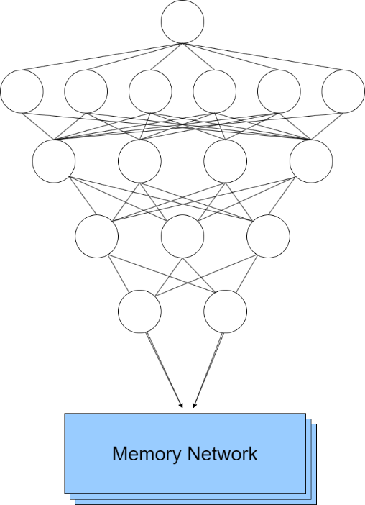
Figure 1. Encoder
(a).
(b).

(c).
(d).

(e).

Description: Each level in the decoder can be specified to possess certain values, or can be instantiated with the outputs of a discrete, symbolic modular system. Additionally, compared to a fully encapsulated system, this structure allows complex reorganization in the training process. A fully encapsulated, modular system can be derived from the training paradigm. This trained, modular system can then be applied to out of distribution tasks. (a) The processing of a singular observed object into the encoder network. (b) The process of feature extraction. (c) The distillation of relevant features. (d) The most relevant features are reduced to a set of memory activation keys that will later act upon the memory network. (e) The encoder output instantiates some change in the memory network, given its specific key value.

Figure 2. Decoder Network
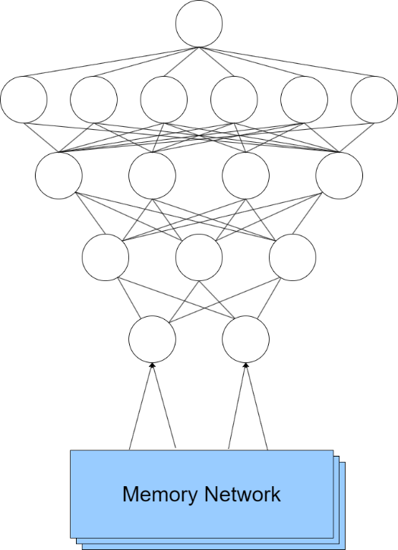
(d).

(c).

(b).

(a).

Description: The decoder network operates similarly to the encoder network, however, the decoder disambiguates the changes in the activation patterns within the memory network as a result of the encoding key value. (a) As a result of the encoder key value, the specific activation functions within the memory network are updated. (b) Most relevant activation patterns are attenuated to. (c) Information is processed up to a set of discrete nodes and learned weights. (d) The discrete nodes and learned weights in (c), in addition to a task demand, are aggregated in a Task Best Algorithm to select for the satisficing option.
Figure 3. Memory Network
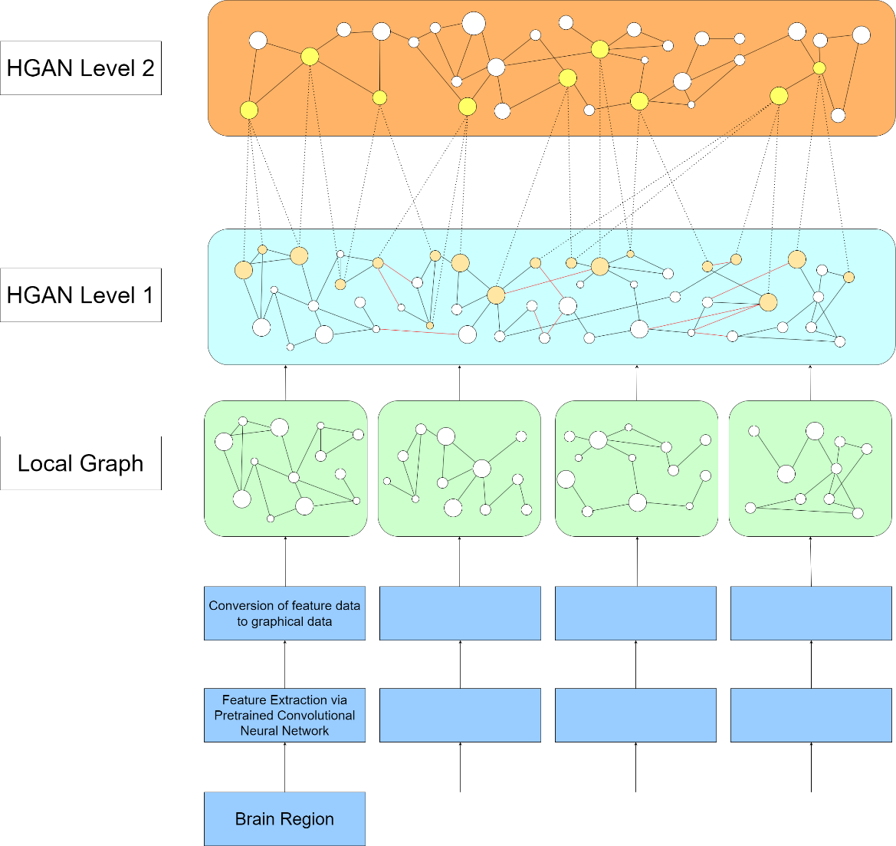
(e).

(d).

(c).

(b).

(a).
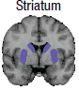
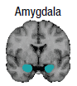
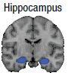

Description: (a) Localized brain activation data is processed through a pretrained convolutional neural network, which identifies relevant features and activation patterns. (b) The strength and boundaries of activation patterns are recorded. (c) Activation pattern data is transformed into localized graph networks. (d) Local graph networks are synthesized into an HGAN. (e) The original HGAN is abstracted, such that each node represents a pattern of activated lower level nodes.

Discussion
Strengths
The proposed HGAN model represents a significant advancement in the integration of cognitive and computational modeling. One of its core strengths lies in its interpretability. By leveraging a hierarchical structure, the model transparently captures the relationships between cognitive subsystems, memory activations, and contextual factors. Unlike traditional connectionist models, which often operate as black-box systems, the HGNN framework provides a clear mapping of inputs to outputs, making it possible to analyze and validate the internal mechanisms underlying its predictions. Another notable strength is the model’s scalability. By incorporating symbolic constraints within deep learning layers, alongside attention-based learning mechanisms, the model integrates empirically validated constraints that can better guide the model in its training phase.

Potential Model Limitations
While the HGAN model has significant strengths, it also faces potential limitations that warrant consideration. One of the primary challenges is the reliance on high-quality data for training. Neural imaging data, which informs the memory network, may be limited in availability and subject to noise. To mitigate this, the model leverages pretrained convolutional neural networks to extract relevant features, reducing the dependence on raw imaging data and improving the generalizability of the graphical representations.
Another challenge lies in the inherent complexity of the hierarchical structure. As the model scales to include additional subsystems and contextual variables, there is a risk of increased computational overhead and reduced efficiency. This concern is initially addressed by the inclusion of attention mechanisms and feature distillation processes within the encoder, which streamline the processing pipeline by focusing on the most relevant inputs. However, as the model progresses through its training and the deep learning layers in the encoder and decoder learn, these sequences of layers can be treated as encapsulated modules for subsequent iterations of the model. This modular encapsulation would significantly reduce computational costs for future applications while preserving the learned representations and functionality of the original model. Additionally, this approach allows for the isolated testing and analysis of individual layers, offering researchers deeper insights into specific subsystems and their contributions to the overall architecture.

Future Directions
The HGAN model opens several avenues for future research and development. One promising direction is the exploration of its utility in real-time applications, such as adaptive learning systems and human-AI interaction platforms. By refining the decoder module to generate task-specific outputs, the model could be adapted to environments requiring rapid decision-making and contextual adjustments.
Further investigation is also needed to extend the model’s applicability beyond reading comprehension. By integrating additional cognitive processes, such as emotion recognition and decision-making, the HGAN framework could provide a more holistic representation of mental states. Additionally, exploring the role of ecological and social factors in memory activation could enhance the model’s ability to generalize across diverse populations and contexts.
Finally, the theoretical implications of the HGAN model warrant deeper exploration. By operationalizing theories of embodied cognition and memory activation, the framework provides a unique opportunity to test and refine hypotheses about the interplay of perception, memory, and reasoning. Future work could focus on validating these hypotheses through experimental studies, using the model as a tool for both simulation and prediction.

The proposed Hierarchical Graph Attention Network (HGNN) model represents a significant advancement in cognitive and computational modeling, providing a dynamic and interpretable framework for understanding the intricate processes underlying memory, reasoning, and reading comprehension. By leveraging enactivist principles of embodied cognition, the model operationalizes the interaction between perceptual stimuli and memory activations, capturing the continuous updating of mental representations as influenced by both prior experiences and contextual demands.
The HGAN architecture integrates modular subsystems with attention-based mechanisms, enabling the model to represent phonographic, orthographic, and syntactic features, alongside contextual and linguistic constraints. This integration advances our understanding of memory retrieval and its influence on downstream comprehension by illustrating how overlapping neural activation patterns drive reasoning and inference processes, offering a concrete framework to explore how cognitive and contextual factors shape underlying mental representations.

Give some background on things like wordnet, verbnet, synsets, dependency labels, etc. The goal is to show what information will be used as constraints within the model architecture.
Additionally, we want to describe how this information will be used to serve as constraints. Here we will show how physics informed neural networks have utilized imposed function constraints as node values, guiding the training of encoder-decoder models.

Encoder Model Architecture:

Description of Figure 1 (Encoder)
In general, each level in the encoder can be specified to possess certain values, or can be instantiated with the outputs of a discrete, symbolic modular system. Additionally, compared to a fully encapsulated system, this structure allows complex reorganization in the training process. A fully encapsulated, modular system can be used to produce outputs that would be used to constrain a particular layer. (a) Contains an attention map that allows the model to attenuate to various objects in the environment. This attention map is refined during the backpropagation of the training phase. (b) The implementation of sub features as constrained nodes derived from relevant modular or connectionist sub systems. I.e. phonographic, orthographic, syntactic processing units, etc. (c) Distillation of relevant features, via encoding. Aggregates the influence of such features on an output node. (d) Output node corresponds to a memory key value that (in combination with other perceptual encoder networks) lead to particular activation of memory.

The architecture supports an enactivist interpretation of embodied cognition that simultaneously accounts for and integrates perceptual inputs from the environment and individual information processing subsystems into memory. As such, inputs from across perceptual modalities are distilled and consolidated to operate on a shared underlying graphical representation of active brain regions and neural activity. First, neural imaging of brain regions is conducted. Second, relevant features are extracted via pretrained convolutional neural networks. Third, identified brain activation patterns are converted to graphical representations and labeled with respect to the relevant behavioral data. In this case, the sequencing of word identification. The result are graphical representations of neural activation patterns of word identification for respective brain regions. Varying activations result in differentiable weighting of nodes and edges. Fourth, the aforementioned graphical representations are aggregated to create a unified Hierarchical Graph Attention Network. Connections between nodes that share sequentially correlated [is this the right phrase?] activation patterns are established. Fifth, an additional layer is created, synthesizing activated nodes into consolidated graphical representations, allowing for a compressed representation of more sophisticated underlying brain activation patterns.

Memory Network Architecture:
The memory network is a Hierarchical Graph Attention Network distilled from brain imaging data. [Relate to the point about how brain imaging data doesn’t give us a lot of information. Then explain how this memory network solves that.]

Daniel D Hutto
Shaun Gallagher
Results

Leveraging experimental results on text comprehension, such as [list], isolable features such as phonographic or orthographic processing [how a person normally operates] are built into the model. With such constraints built into the model. With such constraints built directly into the model, we expect a generalized functioning between such processing modules across contexts.

INFORMATION PROCESSING
After the set of perceptual systems affect the memory system, we have an update. I.e. there is some pre-existing configuration of activation patterns. The perception of stimuli at Tn+1 leads to a progression of activations of the HGAN. This progression is representative of the effect of such stimuli on underlying brain region activation patterning. The activation patterns of each respective brain region will serve as the inputs for later perceptual tasks. I.e. there is a phenomenological question about how one determines value of an object via perceptual means. We argue here that phenomenological sense is derived from a combination of prior experience (accessed through this memory network), and that the unique activation pattern, plus additional perceptual information via these perceptual systems is what instantiates novel experience.

REASONING & MEMORY
Reasoning is traditionally understood as pattern recognition, deduction, inference, and many other interpretations. Such theories additionally suppose a multitiered memory system, where short- and long-term memory constraints influence one's ability to reason.
Such theories contend that in the process of reasoning mental objects are accessed and manipulated either simultaneously or in rapid succession within working memory to determine the veridicality of some facts or predictions. Variable response rates given scaffolds, and improved performance given additional time has led many to the conclusion that such variation confirms a multi-part memory system. Such systems are theorized to provide quickly accessed heuristics from long term memory. However, more accurate reasoning occurs when engaged in deliberative mental operations of mental objects within working memory.

NEUROLOGICAL ISSUES WITH CONTEMPORARY MEMORY STRUCTURES
However, multi-part memory systems like the one described above are computationally inefficient and assume the evolution of competing [memory/reasoning] systems with distinct and sometimes computational capacities. Such theories look to distinct activation patterns across disparate brain regions as evidence for such competing [memory/reasoning] systems.
Growing evidence, however, seems to indicate that [what I want to say is that the activation of seemingly disparate brain regions are not merely neurological redundancies but contribute to memory activation itself].
Additionally, while localization of memory processes does occur in the brain, there is little clarity on how information is transformed from short to long term memory and the ability of reasoning modules
Additionally, there is serious contention over whether heuristics are differentiable from other mental objects and belong in a distinct category. Instead of categorizations of heuristic or probabilistic reasoning, some contend that such underlying mental objects can be understood instead across dimensions of sparsity or relational character. As such, the degree to which a mental representation possesses characteristics that lead to more or less accurate reasoning operations.
REASONING
Practically speaking, a reasoning algorithm must make sense of two components: (1) the characteristics and dimensions of the objects being reasoned over, and (2) the selection algorithm that selects (and/or orders) mental objects in some sequential transformation process. The relationship between these two components determines the ability of an IPS to engage in effective reasoning. In other words, reasoning is dependent on "the structure of task environments and the computational capabilities of the actors (Simon, 1990, p. 7)."
Due to its computational efficiency and ability to model [], we make use of the Take Best Algorithm of reasoning. In this model, mental representations are produced as a result of a complex interaction between previous mental states and the objects derived from perceptual stimuli. Activation of underlying memory, in combination with discrete mental processes produce contextually unique and relevant mental representations given the set of externally observed objects. Given additional stimuli, such as a direction or task demand, these representations (and their underlying values) are used to make predictions on next action states or to satisfy a generative process that leads to a "satisficing" optimum. This satisficing optimum aggregates the set of underlying mental representations and computes a deliberative choice that will satisfy a local, short term optimum. I.e. determining an action that will result in maximizing a contextually relevant reward function. This reward function is variable, given the characteristics, dimensions, and sequencing of the underlying mental representations.

I.e. we may be able to say that there are underlying conditions that must be satisfied, and that our minds are engaged in a process where we don't have access that information at that lower computational level. Instead, we operate at our own symbolic level. And at this symbolic level we are able to decompose objects into features and sub objects, which allows us to redefine and re-analyze objects across N time steps. These new appraisals, in addition to continuously updated mental states, create new objects and mental states whose processing may eventually allow us to address some underlying motivators.

